**Project Design Phase-II**

**3.3Data Flow Diagram & User Stories**

|  |  |
| --- | --- |
| Date | 23 June 2025 |
| Team ID | LTVIP2025TMID32100 |
| Project Name | Citizen AI |
| Maximum Marks | 4 Marks |

**Data Flow Diagrams:**

A Data Flow Diagram (DFD) is a traditional visual representation of the information flows within a system. A neat and clear DFD can depict the right amount of the system requirement graphically. It shows how data enters and leaves the system, what changes the information, and where data is stored.

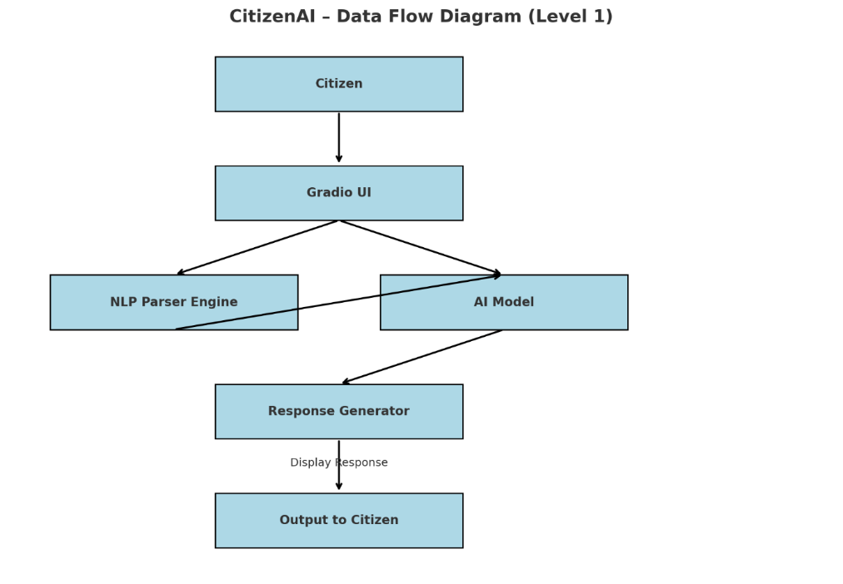

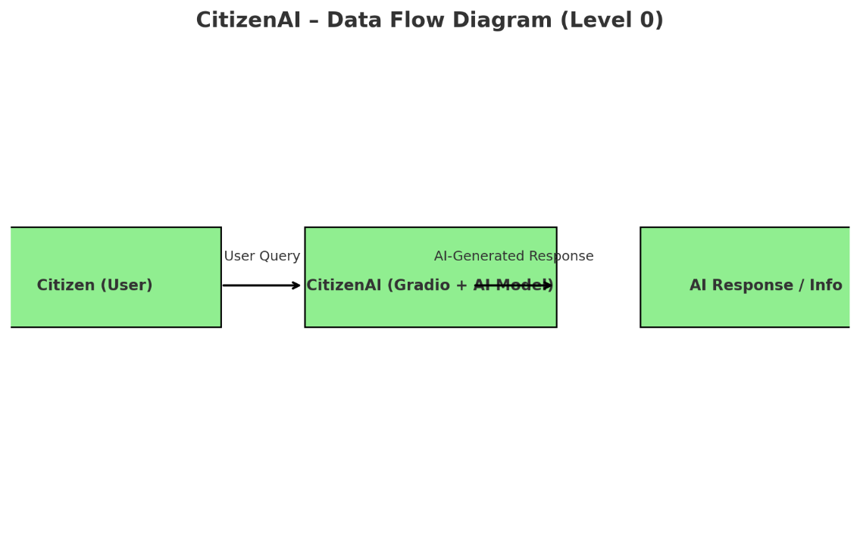

**User Stories**

Use the below template to list all the user stories for the product.

| **User Type** | **Functional Requirement (Epic)** | **USN** | **User Story / Task** | **Acceptance criteria** | **Priority** | **Release** |
| --- | --- | --- | --- | --- | --- | --- |
| Citizen (Web/Mobile) | Report Civic Issue | USN-1 | As a citizen, I can report a civic issue by typing in my complaint in natural language. | I can submit an issue and receive a confirmation instantly. | High | Sprint-1 |
| Citizen (Web/Mobile) | Ask Govt. Service Info | USN-2 | As a citizen, I can ask questions about schemes or services. | I get accurate AI-generated answers for my query. | High | Sprint-1 |
| Citizen (Web/Mobile) | |  | | --- | | Follow-up Questions |  |  | | --- | |  | | USN-3 | As a citizen, I can ask follow-up queries in . | I can continue the conversation without restarting it. | Medium | Sprint-2 |
| Citizen (Web/Mobile) | Language Support (Future) | USN-4 | As a citizen, I want to interact in my local language. | I can use Telugu/Hindi for questions and receive responses. | Low | Sprint-3 |
| Citizen (Web/Mobile) | Feedback Submission | USN-5 | As a user, I want to leave a rating or comment after using the platform. | I see a short feedback prompt at the end of my session. | Medium | Sprint-2 |
| Admin | View Complaint Analytics | USN-6 | As an admin, I want to view total complaints by category and area. | I see a dashboard showing visual stats by issue type/location. | High | Sprint-2 |
| Admin | Export User Queries | USN-7 | As an admin, I want to export all queries | As an admin, I want to export all queries submitted by users. | Medium | Sprint-3 |
| Support Executive | Respond to Escalated Issues | USN-8 | As a customer care executive, I want to view and respond to escalated complaints. | I can access issue details and add comments or mark them resolved. | High | Sprint-3 |
| Support Executive | View Chat History | USN-9 | As a support user, I want to view past user-chat history for context. | I can view previous chats linked to a user or issue. | Medium | Sprint-3 |